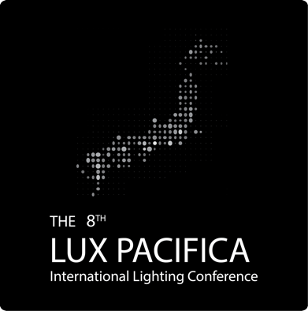

The 8th Lux Pacifica Program Book

Life and Lighting

March 6-8, 2018
Tokai University, Takanawa Campus, Tokyo, Japan

Instruction

- Oral Session
Each presenter must make slides in Microsoft Powerpoint formats (.ppt and .pptx). We will prepare Microsoft Office 2016 working with Windows Laptop machines for presentation at the theaters. If a presenter uses his or her own computer for presentation, the computer must have a D-Sub connector. HDMI connectors are not installed into our LCD projectors. Slides must be stored in our laptop computer during a break just before a session at which presentation will be performed. Presenter will give talk for 12 min and discuss with the delegates for 2 min.

- Poster Session
Each presenter must make a poster (less than 900 mm (W) x 1,800 mm (H)). He or she must put a poster on a board before 9:00 am and take out before 2:00 pm on the designated day (see this program). Presenter must put it on the board with a designated number.

- Lecture
Each lecturer also must make and prepare slides as described above. He or she will discuss with delegates for the last 5 min.

- Workshop
Presenters also must make and prepare slides as described above. Each presenter will give talk for 25 min. For the last 20 min, they will have a panel discussion on the stage and Q+A under the direction of the workshop chair.

Wi-Fi service
Eduroam service is available in the buildings on Takanawa Campus. This service is provided to the delegates from the universities and colleges which belong to the Eduroam consortium. Please ask a person in charge of networking in your university or college about Eduroam service before joining the 8th Lux Pacifica conference. Other Wi-Fi services are not provided at the venue.

Conference kit
Conference kit (program book, name badge and others) will be provided at the reception since 8:30 am on March 6. If you have business card, please bring it to the venue. Your business card can be inserted into a badge. Otherwise, you must write your name on a piece of paper for a badge.
Schematic diagram of Takanawa campus

Day 1 (March 6)

Theater 1 (Building #2 2B-101)

Day 2 (March 7)

Theater 2 (Building #4 4101) and Theater 3 (Building #4 4104)

Day 2 (March 7)

Theater 2 (Building #4 4101): Oral Session #1, #3 & #5

Day 2 (March 7)

Theater 3 (Building #4 4104) : Oral Session #2, #4 & #6

Day 2 (March 7)

Exhibition Hall: Poster Session #1

Day 3 (March 8)

Theater 1 (Building #2 2B-101)

Day 3 (March 8)

Exhibition Hall: Poster Session #2

Delegates who had registered till December 2, 2017
(continued)

Organizing Members

Sponsored by the Illuminating Engineering Institute of Japan
Supported by Tokai University (Takanawa Campus & Kenkyu Suishin Kiko),
Suzuki Foundation, Mikiya Foundation,
Asahi Rubber Inc., EBA Japan Co. Ltd, Konica Minolta Inc. and Visual Technology Laboratory Inc.

