Paper

Non-linear Uniform Color Space Considering Non-linearity and Non-symmetry in Opponent Color Response Mechanisms

Koichi IKEDA*✝, Taro YAMADA** and Hanako TANAKA**

*Tokyo University of Science, Department of Electrical Engineering, Faculty of Science and Technology
**Chiyoda University

✝Corresponding author: Koichi Ikeda editing@ieij.or.jp

ABSTRACT
A new non-linear uniform color space NC-IIIC is developed for color specification. First, NC-IIC space is derived by applying non-linearity at the receptor level to linear color space NC-I composed of linear transformations of tristimulus values X, Y and Z. Then, NC-IIIC space is constructed by further introducing non-linear and non-symmetric functions in Y-B and R-G opponent color response mechanisms to NC-IIC space. For colors aligned on a plane of constant value in Munsell space, coefficients of the above non-linear response functions are optimized by computer numerical analyses to make hue circles shape as close as possible to uniform circles in the new space. The uniformity of the space is significantly improved, and the average deviation between hue circles and uniform circles in the new space is reduced to about 1/10-1/20 of those in conventional L*a*b* and L*u*v* uniform color spaces by applying appropriate non-linear opponent transformations. Hue, lightness and chroma can be represented independently as mutually orthogonal attributes with proper correspondences of hue with hue angle, lightness with metric lightness and chroma with metric chroma in the new color space NC-IIIC.

KEYWORDS: non-linear uniform color space, opponent color response mechanisms

- Introduction

The color space is requested to satisfy the following conditions for specifying color in accordance with a common standard. (1)Attributes of color can be represented normally to allow mutual comparison of characteristics among colors. (2)Specification of color can be made in correspondence with physiological mechanisms of the visual system. (3)Metric quantities can represent psychological aspects of color corresponding to perceived attributes. (4)Geometrical distance in the space is well corresponded to perceived color difference with appropriate uniformity. (5)Mathematical and geometrical structures are clear and lucid to assure simplicity and convenience in both calculation and specification of coordinates.
On the other hand, on the color appearance model where chromatic adaptation is considered for the purpose of specifying how color is appeared, the above condition (1) is different and the following conditions must be fulfilled in addition to the above statements (2) to (5). (6)Hunt effect can be represented to show the fact that color is more vividly perceived as illuminance level becomes higher. (7) Stevens effect can be expressed to show the effect that color of higher lightness against the background is perceived brighter, color of lower lightness is perceived darker, and this effect becomes more conspicuous as the illuminance becomes higher^{1,3,4)}.
Helson effect can be indicated to express the phenomenon perceived as a color of the opposite hue of light source. In other words, the color appearance model should be capable of representing how color is perceived under various circumstances, such as color of illuminant, illuminance level, luminance and color of the background, whether object is luminous or non-luminous, the size of the object, reflectance / luminance and color of the object, area of visual field, viewing conditions and so forth²⁾. Meanwhile, when specifying color in a standard manner, achromatic color must be represented as achromatic under any condition, and hue, lightness and chroma of the color must be solely defined as attributes of the object regardless of illuminance level and conditions of the background. These are the important differences between the conditions for the space to specify color in a standard manner and those for the color appearance model to represent how color is appeared. The CIE has recommended the use of L*a*b* uniform color space and L*u*v* uniform color space for color specification¹⁾⁴⁾ Also, for color rendering indices, the use of U*V*W* space was proposed. However, these spaces did not take attributes of perceived color, such as hue lightness, and chroma⁵⁻⁷⁾.

<Figure 1>

Up to this time, non-linearities at the receptor level are expressed by non-linear functions of Ｘ, Ｙ and Ｚ or Ｒ, Ｇ and Ｂ responses. Some of these non-linear functions, such as Munsell value that is used to express lightness, are complicated. Yet recently, approximation is attempted by employing functions that are as simple as possible, and functions of 1/3 power are frequently used, for example, L*a*b* uniform color space of the CIE adopts the same form of non-linear functions as well.
Non-linearity can be introduced after transforming to Ｒ, Ｇ and Ｂ, however, functions of Ｘ, Ｙ and Ｚ to 1/3 power are adopted in this study, because Ｘ, Ｙ and Ｚ are used in color spaces of the CIE. For comparison purposes, further trial to study those to 1/2 power is attempted.
When introducing non-linearity to linear space NC-I in conjunction with the above concept, general expression for coordinates of color in the space is described as follows.

Ｌ* ＝ （Ｙ／Ｙn）^{１／３} －１６
ａ’＝ ＫΓ［ （Ｘ／Ｘn）^{１／ｎ}－［γ（Ｙ／Ｙn）^{１／ｎ}
＋（１－γ）（Ｚ／Ｚn）^{１／ｎ} ］ ］ （５）
ｂ’＝ Ｋ ［ （Ｙ／Ｙn）^{１／ｎ}－（Ｚ／Ｚn）^{１／ｎ} ］ : （ｎ＝２ ｏｒ ３）

Also, by introducing non-linearity of 1/3 power type at the receptor level to Judd linear space, the form of the expression becomes that of well-known L*a*b* uniform color space. Yet, since this is simply for comparison purposes, only 1/3 power type is applied.

ａ* ＝ Ｋ Γ［ （Ｘ／Ｘn）^{１／３}－（Ｙ／Ｙn）^{１／３} ］ （６）
ｂ* ＝ Ｋ ［ （Ｙ／Ｙn）^{１／３}－（Ｚ／Ｚn）^{１／３} ］

The general term for these new color spaces will be defined as NC-II (New Color Space-II), and “S ” (square root) and “ C ” (cubic root) will be indicated at the end for 1/2 and 1/3 power spaces, respectively.
Values of coefficient Ｋ for respective color spaces, by which mean radius of the hue circle of C=8 becomes 40, are shown in Table 1.

<Table 1>

Coordinates of Munsell colors located orderly on the plane of V=6 in new color spaces NC-IIS and NS-IIC are shown in Figure 1, in comparison with those in Judd, NC-I, L*a*b* and L*u*v* color spaces.

＊＊snip＊＊

8. Concluding remark
Up to this point, it has been commonly accepted that physiological color perceptive mechanisms are constructed by three primary color responses at the cone level and opponent color responses at horizontal cell level, respectively, since Young-Helmholtz three-component theory, Hering opponent-colors theory and Hurvich & Jameson chromatic valence theory. Today, a unified staged theoretical color perceptive model, which incorporates all of these theories, is widely accepted.
These perceptual responses must be considered non-linear and non-symmetric naturally, because these mechanisms are based on physiological responses. However, with regards to spaces for color specification, there have been no equations introducing expressions of non-linearity and non-symmetry in opponent color response mechanisms, while there were equations expressing non-linearity at the cone level.
In this study, new non-linear and non-symmetric uniform color space NC-IIIC for color specification has been developed successfully by applying non-linearity at the receptor level in linear space and by introducing response functions which express non-linearity and non-symmetry in opponent color response mechanisms.
As a result, loci or hue circles of colors of constant value and constant chroma in Munsell system can be represented as concentric circles that are placed with even spacing according to the magnitude of chroma.
On reflection, above characteristics of Munsell system are extremely remarkable considering the fact that coordinates of Ｘ, Ｙ and Ｚ of Munsell colors were estimated manually in a period when computers were non-existent.

We should pay great respect to this prominent achievement of arranging such lots of coordinates by external and internal insertions of enormous data obtained through psychological experiments in a systematic way by human hand.

Honestly speaking, I reconfirmed the fact that Munsell system is constructed in an ultimately systematic manner, and rediscovered that it is appropriately structured to make up Euclidean uniform color space.
In this non-linear uniform color space, hue circles can be represented as uniform circles, and hue and chroma can be independently corresponded with hue angle or metric hue and distance from the origin or metric chroma, respectively. Hence it will be possible to specify colour in correspondence with characteristics of human color vision.

Moreover, the change in hue and that in chroma can be independently corresponded with the change in hue angle and that of distance from the origin or in radius of hue circle, respectively⁶⁾. This means the color difference can be specified in accordance with the attributes of human color perception.
Likewise in the linear colour space, the expression by the equations can be applied to color under any illuminant because von Kries type compensation is introduced in the non-linear color space.
In the future, we plan to verify micro uniformity of the new space, particularly relating to hue angle, by applying this color space to results of color difference evaluation tests.
We also wish to make an attempt at elucidating the geometric structure of this color space by applying the concept of non-linearity and non-symmetry in opponent color response mechanisms to NCS color system.

References

(1) CIE:COLORIMETRY - second edition - 1986,Publication CIE, No. 15.2 (1986).
(2) Newhall, S.M., Nickerson, D. and Judd, D.B.: Final Report of the O.S.A. Subcommittee on the Spacing of the Munsell Colors, Jour. Opt. Soc. Amer., Vol. 33 , pp. 385-418 (1943).
(3) Japanese Standard Association: Color specification－Specification according to their three attributes, JIS Z 8721 (1993).
(4) Wyszecki Gunter: TC-1.3 COLORIMETRY PROGRESS REPORT, Publication CIE, No. 36, pp.161-172 (1976).
(5) Ikeda, K., Yamashina, H. and Ichihashi, A.: Color rendering properties of light sources ： New color space for evaluation, Lighting Research and Technology, Vol.. 28(2), pp. 97-112 (1996).

Part of this work was presented at 10th annual conference of IEIJ, July 2011, Tokyo, Japan.

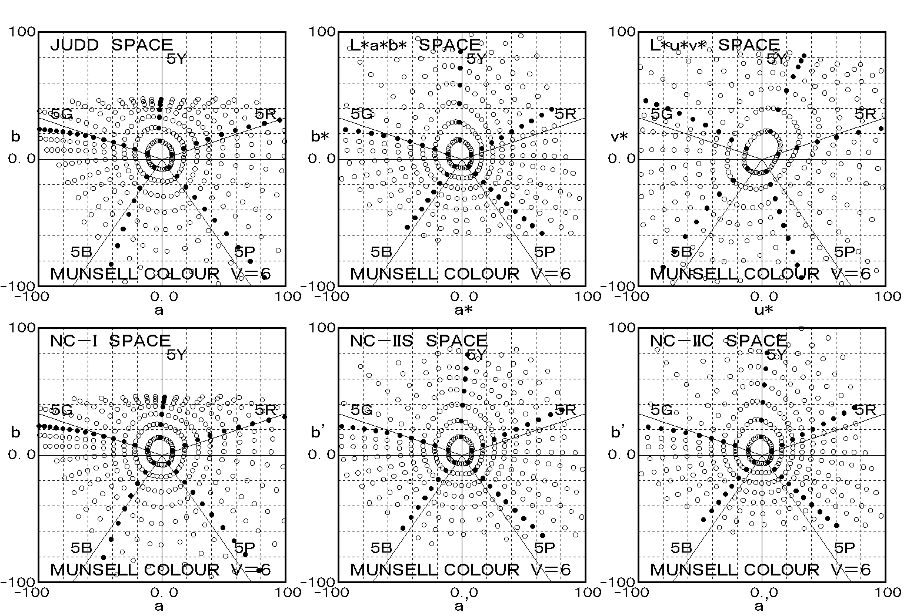

Figure 1 Coordinates of Munsell colors with value of 6 in Judd , NC, L*a*b* , L*u*v* , NC-S and NC-C spaces

Table 1 Values of K in non-linear color spaces NC-Ⅱ

1/2 SPACE | n=2 | NC-S | K=160
1/3 SPACE | n=3 | NC-C | K=190
1/3 SPACE | n=3 | L*a*b* | K=200

