Visa Details
All foreign visitors and participants of the trade fair must apply for visa and comply with the health requirements if any on entering India.
Please ensure to obtain visa prior to departure from your country.
We would be pleased to assist you with the provision of supporting documents for visa application.
VISA POLICY INDIA
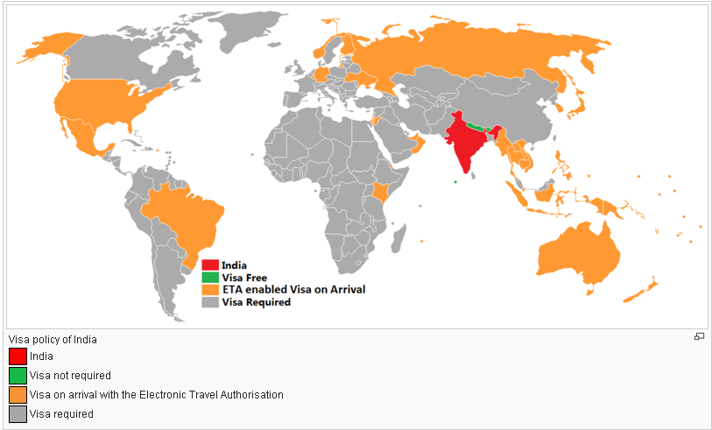
For further enquiries, please fill following Information as body of e-mail, set subject as “Visa Inquiry” and send it to us at one of the contact details provided below.
Passport Details
Name Of Applicant:
Father’s Name/ Husbands Name:
Nationality:
Date Of Birth:
Place Of Birth
Passport Number
Date Of Issue
Place Of Issue
Date Of Expiry
Address
* Please ensure all Visa Applications are completed by 15.09.2015.

Contact Us:
Mr. Rahul Sengupta
M: +91 983 034 8531
E: rahulsengupta@exponext.net

Mr. Dipten Basu
M: +91 983 004 7211
E: diptenbasu@exponext.net

For Further Details Visit the Website Provided Below:
https://indianvisaonline.gov.in/
http://india.travisa.com/

